8-Puzzle Problem
Aim
To solve the 8-Puzzle problem using Artificial Intelligence techniques and reach the goal state from the given initial state.

Objectives
- To understand state-space search.
- To apply AI search algorithms.
- To find a sequence of moves to reach the goal state.
- To minimize the number of moves.

Algorithm
- Start.
- Define the initial state and goal state.
- Find the position of the empty tile (0).
- Generate all possible moves (Up, Down, Left, Right).
- Move the empty tile to a valid position.
- Check if the current state matches the goal state.
- If yes, display the solution.
- Otherwise, repeat Steps 4–7.
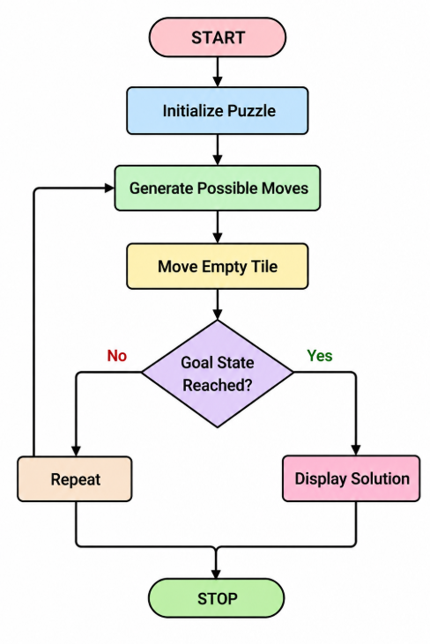

Source code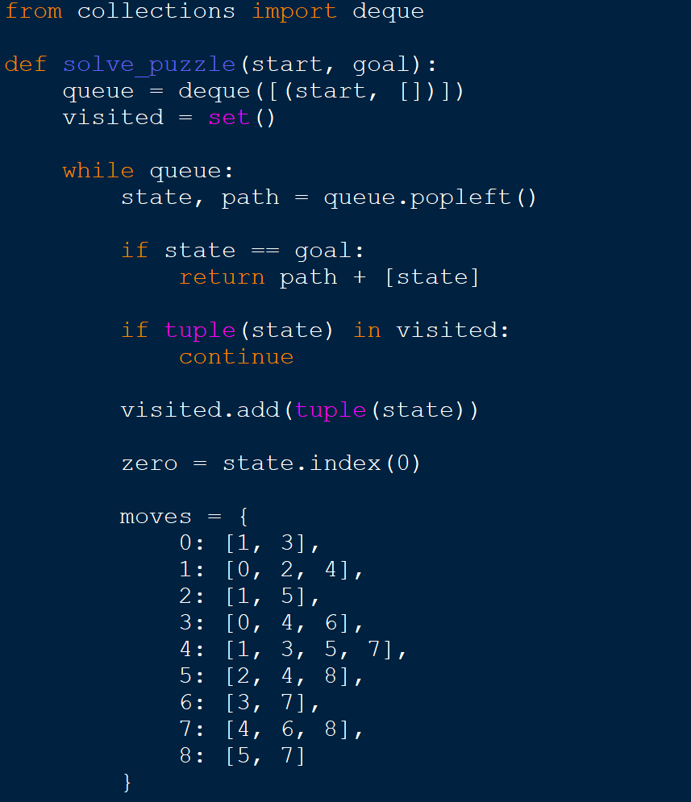

OUTPUT:
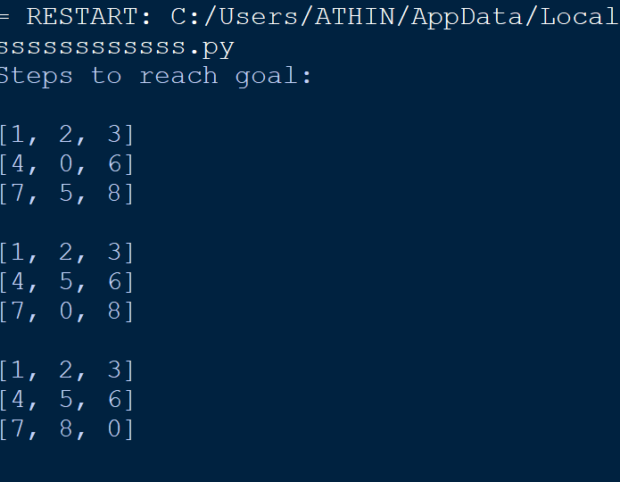

Result
The 8-Puzzle problem was successfully solved using the Breadth First Search (BFS) algorithm. The algorithm found the sequence of moves required to transform the initial state into the goal state.

